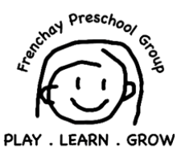 Food safety Policy

At Frenchay Preschool Group we ensure that all food preparation is done hygienically to prevent cross contamination and illness.
A list of allergies are kept in the kitchen and all practitioners are made aware of them
Keeping Clean
- Wash your hands before handling food
- Wash your hands after going to the toilet
- Wash and sanitize all surfaces and equipment used for food preparation
- Protect kitchen areas and food from insects pests and other animals
Avoiding cross-contamination & unwanted bacteria
- Separate raw and cooked food
- Use separate equipment and utensils such as knives and chopping boards
- Store food in containers to avoid contact between raw and prepared foods
- Cook thoroughly especially meat, poultry eggs and seafood
- Bring food like soups and stews to the boil
- Reheat cooked food thoroughly
- Keep food at safe temperatures
- Do not leave cooked food at room temperature for more than 2hrs
- Refrigerate promptly all cooked and perishable food below 5c
- Cooked food must be kept at 60c prior to serving
- Do not store food to long even in the fridge
- Do not thaw frozen food at room temperature
- Ensure all fruit and vegetables are washed thoroughly
- Do not use food beyond expiration date

Written by: | Claire Frost
This policy was adopted by the pre-school on: | 25th Feb 2014
Signed off by the Deputy Manager of Frenchay Pre-School | Gemma Hughes
Next Review Date | November 2027
Links to EYFS | Safeguarding children and promoting children’s welfare / Organisation

